|  |
| --- |
| **Covid-19 detection from Chest X-ray images using Deep Learning CNN models** A Project Report Submitted for Minor Project (CS6490) of 6th Semester for partial  fulfillment of the requirements for the award of the degree of Bachelors of Technology in  **Computer science and Engineering**  submitted by  **Deeti Hothrik 1806080**  **Sudhanshu Kumar 1806083**  **Shubhangi Singh 1806179**  Under the Supervision of Prof. Shyam Rajput Asst. Prof. CSE Department NIT Patna    **Department of Computer Science & Engineering**  **National Institute of Technology Patna**  **Patna-800005**  **Jan-May, 2021** |
| CERTIFICATE This is to certify that Deeti Hothrik Roll No. 1806080, Sudhanshu Kumar Roll No. 1806083, Shubhangi Singh Roll No. 1806179has carried out the Minor project (CS6490) entitled as **“**Covid-19 detection from Chest X-ray images using Deep Learning CNN models **”** during their 6th semester under the supervision of **Prof. Shyam Rajput,** Asst. Prof., CSE Department in partial fulfillment of the requirements for the award of Bachelor of Technology degree in the department of Computer Science & Engineering, National Institute of Technology Patna.  ……………………………. .….….…………………….  **Prof. Shyam Rajput Dr. J.P Singh**  Assistant Professor Head of Department  CSE Department CSE Department  NIT Patna NIT Patna |
| DECLARATION We the students of 6th semester hereby declare that this project entitled  “ **Covid-19 detection from Chest X-ray images using Deep Learning CNN models**” has been carried out by us in the Department of Computer Science and Engineering of National Institute of Technology Patna under the guidance of **Prof. Shyam Rajput**, Department of Computer Science and Engineering, NIT Patna. No part of this project has been submitted for the award of degree or diploma to any other Institute.  **Name Signature**  Deeti Hothrik ……………………………….  Sudhanshu Kumar .………………………………  Shubhangi Singh ……………………………….  **Place: Date:**  **NIT Patna ………………..** |
| **ACKNOWLEDGEMENT**  We would like to acknowledge and express our deepest gratitude to our mentor **Prof. Shyam Rajput**, Assistant Professor, Computer Science & Engineering Department, National Institute of Technology Patna for the valuable guidance, sympathy and co-operation for providing necessary facilities and sources during the entire period of this project.  I wish to convey my sincere gratitude to the Head of Department and all the faculties of Computer Science & Engineering Department who have enlightened me during our studies. The faculties and cooperation received from the technical staff of the Department of Computer Science & Engineering is thankfully acknowledged.   1. Deeti Hothrik (Roll No. 1806080) 2. Sudhanshu Kumar (Roll No. 1806083) 3. Shubhangi Singh (Roll No. 1806179) |
| Contents  Page No.   1. Certificate 2 2. Declaration 3 3. Acknowledgement 4 4. Contents 5  Abstract 6  * 1. **Introduction 6**  Data-Set Interpretation 7Structure of Models 7-9  * + 1. Transfer Learning 7     2. ResNet 8     3. DenseNet 8     4. VGGNet-16 9   **4. Experiment Results 9-15**    4.1 Model Hyperparameters 9    4.2 Evaluation Metrics 10  4.3 Classification Report 11    4.4 Accuracy Metrics 12    4.5 Confusion Matrix 13-15  4.6 Loss and Accuracy Curve 15  **5. Summary 15-16**    **6. References 16** |

**Abstract**

Due to the COVID-19 pandemic which has affected all around the world, there is a need to detect the disease early enough radiography and radiology images are used to diagnose the patients. As we know the importance of deep learning, which was tremendous in the past in detecting many diseases like pneumonia, lung infections etc. which enables us to train some authentic models and make it ready for the evaluation of detecting COVID-19 patients by their Chest X-Ray images . Dataset consists of 650 Chest X-rays images. Here we are using transfer learning on a subset of 1500 Chest X - ray images to train four most approved convolutional neural networks, which are VggNet, ResNet18, ResNet50,and DenseNet, to detect COVID-19 disease. Evaluation was done for the remaining 500 images achieving accuracy of 92% and specificity of around 75%. Besides this, we also expressed the loss and accuracy curve, precision, recall, F1-score and Confusion matrix for each of the given models.

1. **Introduction**

In this pandemic as there is no authentic medicine or vaccine availability for the majority of the people there is an early need of detection of the suspected patient to isolate and decrease the chance of infection. While RT-PCR takes huge time to diagnose the suspected patient, Chest radiography imaging which has performed well in the past in the detection of pneumonia is used for COVID-19 detection also for easy and fast performance.

Rather than using a machine learning framework to detect and predict this disease from Chest X-Ray images which follows a two step procedure (hand-crafted feature extraction+recognition), we are using a framework named deep learning which directly forecasts this COVID-19 disease from the available raw images without any requirement of feature extraction. Deep learning based models which are precisely convolutional neural networks (CNN) have been surpassing the authoritative AI methods in most computer vision and medical image investigation chores in recent years.

Here, we trained four authentic CNN’s which gave encouraging results in current times which are VggNet, ResNet18, ResNet50,and DenseNet-121 on COVID-Xray dataset. As we are having limited images of COVID-19 affected Chest X-ray images, we directly cannot train these models from the start to achieve good results. Hence we follow some the following approaches:

1. We have used data amplification to generate modified genres of COVID-19 images such as flipping, twisting, minor rotation, supplementing mere amounts of deformations, to enlarge the dataset by a scale of five.

2. Besides training these models from the start, we polish the final layer of the pre-trained genre of these models on ImageNet.

1. **Data-Set Interpretation**

COVID X-ray dataset is formed by two datasets of Chest X-ray images which hold 1500 training and 500 test images.

2.1 Sources

1. Data was accumulated from public sources as well as through indirect accumulation from hospitals and physicians. All images and data were posted in public and mentioned in the following github repository - <https://github.com/ieee8023/covid-chestxray-dataset>. and kaggle.

2. Had been available since May 3, 2020

|  |  |  |
| --- | --- | --- |
| Split | COVID-19 | Normal |
| Training Set | 650 | 850 |
| Test Set | 250 | 250 |

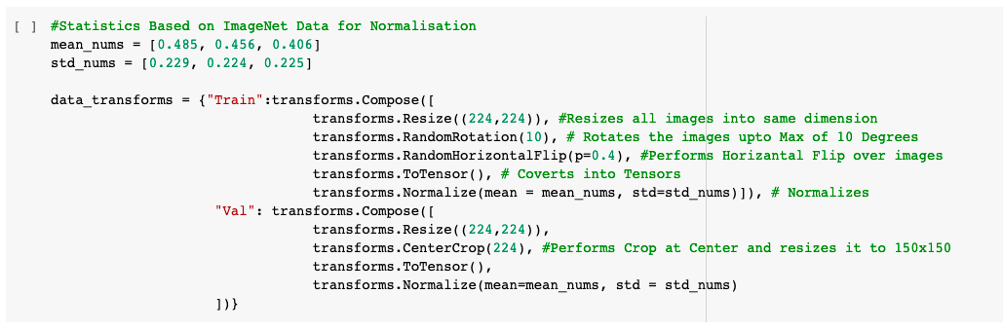

1. **Structure of Models**

3.1 Transfer learning approach

Predominantly we use transfer learning for training models from scratch which do not have adequate training samples, such as medical image classification for scarce or newly appearing diseases.

As the COVID-19 category images are short in supply, we only polished the final layer of the convolutional neural networks(CNN), and made vital use of pre-trained models as a feature extractor. We have evaluated performances of five famous pre-trained models- ResNet18 , ResNet50,VggNet-16 and DenseNet-121

3.2 COVID-19 Detection using residual ConvNet – ResNet18 and ResNet50

ResNet was arguably the most groundbreaking work in the computer deep learning community in recent years, which renders easier gradient flow. The key objective of ResNet is establishing a similar shortcut connection that leaps one or more layers. Now the network will choose an uninterrupted path to the earliest layers in the network, making the gradient updates for those layers much easier.By using ResNet we can now train 1001-layer deep ResNet to outperform its shallower counterparts. Because of its compelling results, ResNet quickly became one of the most popular architectures.

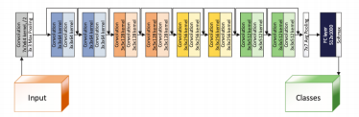

Figure 1: The architecture of ResNet18 model

Implementation of ResNet-18 is as under:

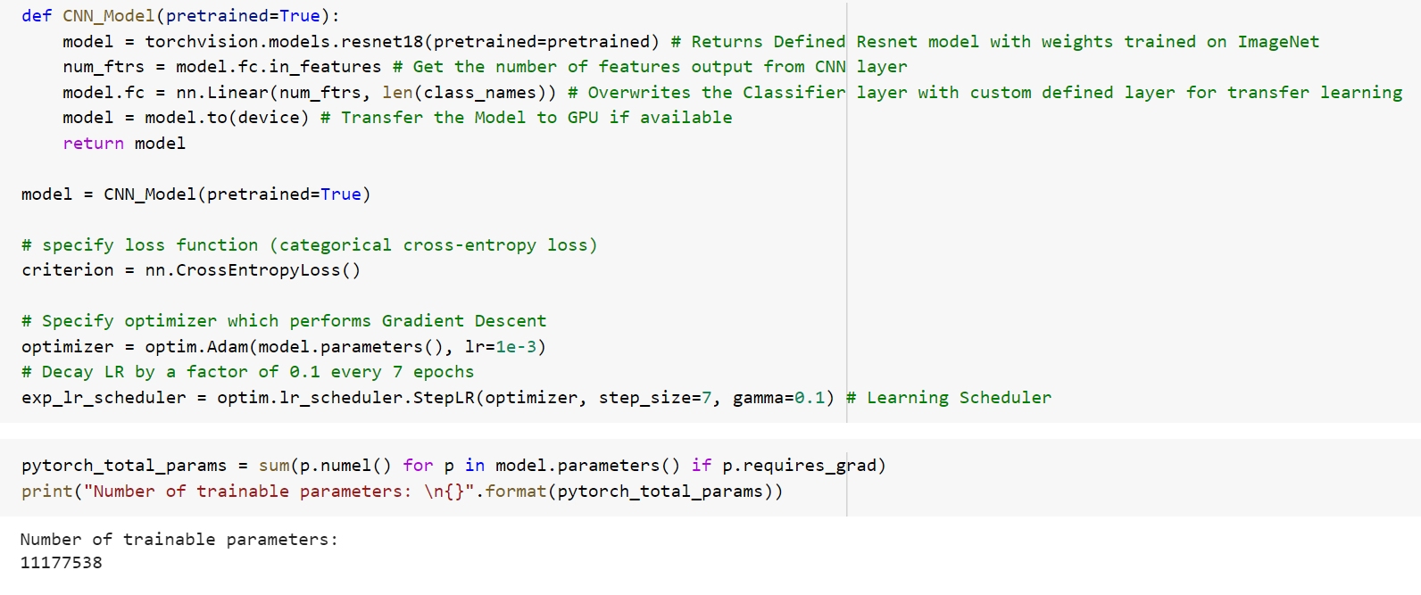

Implementation of ResNet-50 is as under:

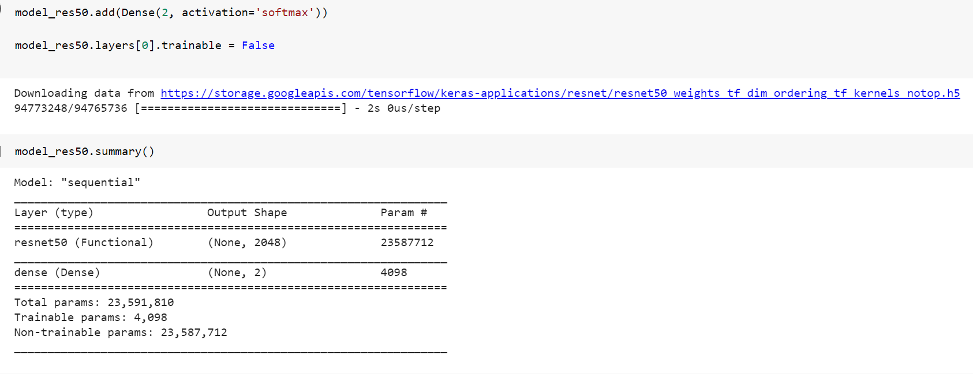

3.3 COVID-19 Detection using DenseNet

Dense Convolutional Network (DenseNet) is a novel architecture which leverages the effects of shortcut connections - it connects all layers directly with each other.In this novel architecture, the input of each layer consists of the feature maps of all earlier layer, and its output is passed to each subsequent layer. The feature maps are aggregated with deep-concatenation. Other than tackling the vanishing gradients problem, it is argued that this architecture also encourages future reuse, making the network highly parameter-efficient. One simple interpretation of this model is that the output of identity mapping was added to the next block, which might hinder information flow which might if the feature maps of 2 layers have very different distributions. Therefore, concatenating feature maps can preserve them all and increase the variance of the outputs, encouraging feature reuse.

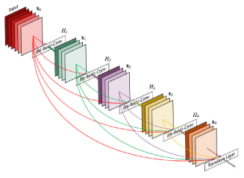

Figure 2: The architecture of a DenseNet with 5 layers, with expansion of 4. 4

Implementation of DenseNet-121 is as under:

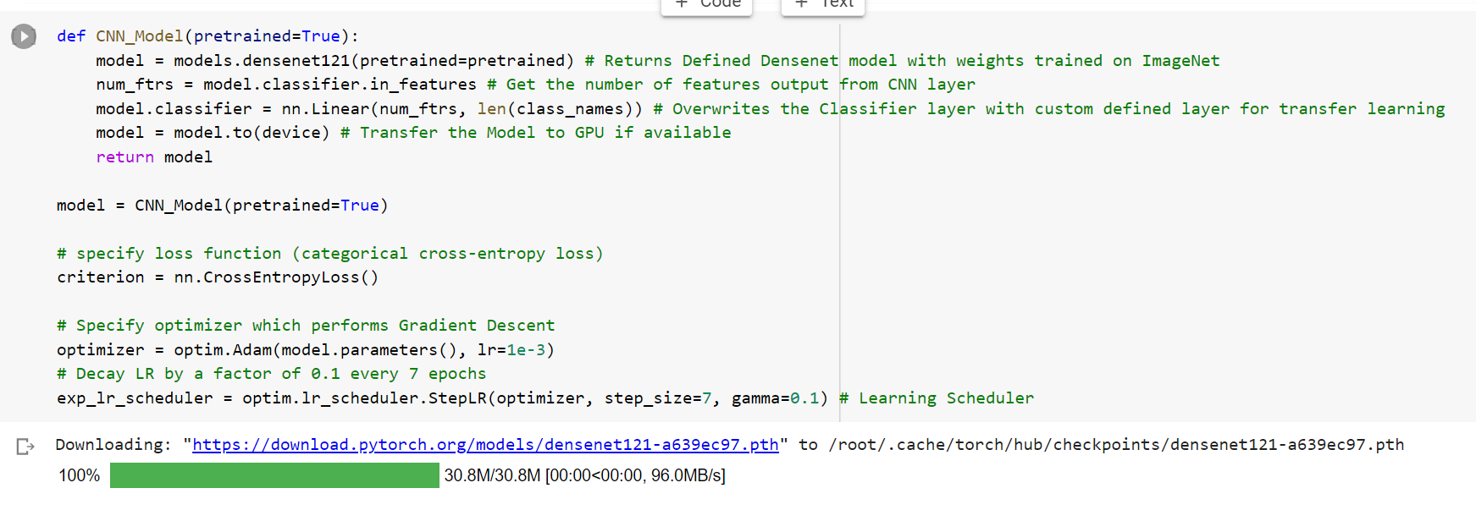

3.4 COVID-19 Detection using VggNet-16

VggNet-16 is considered to be one of the excellent vision model architectures till date. Most unique thing about VGG16 is that instead of having a large number of hyper-parameters they focused on having large convolutional layers of 3x3 filter with stride 1 and always used the same padding and maxpool layer of 2x2 filter of stride 2. It follows this arrangement of convolutional and max pool layers consistently throughout the whole architecture. In the end it has 2 fully connected layers followed by a softmax output. The 16 in VGG16 refers to it having 16 layers that have weights. This network is a pretty large network and it has about 138 million(approx) parameters. Here, the learning rate assigned was 0.001 with batch size of 32 and number of epochs assigned to 10.

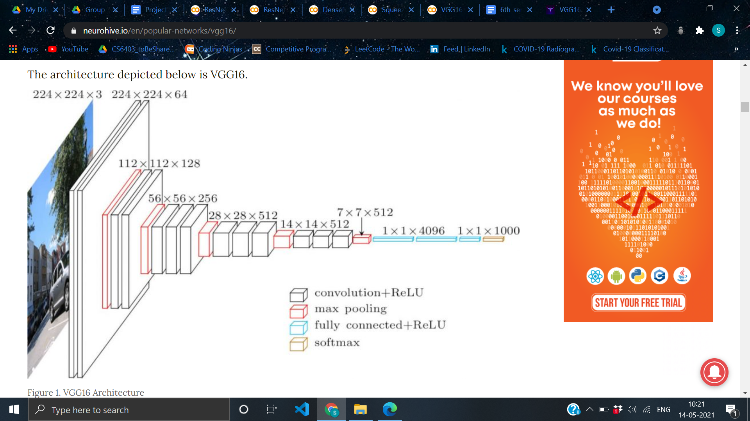

Figure 3 represents the architecture of VggNet-16

Implementation of VggNet-16 is as under:

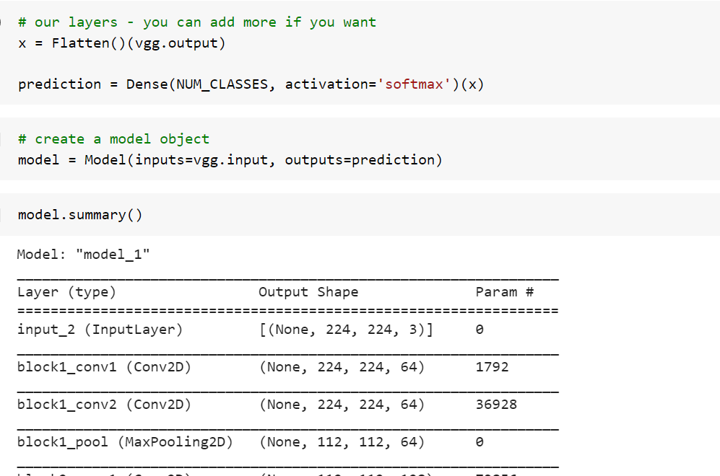

1. **Experiment Results**

4.1 Model hyper-parameters -

We have fine-tuned all models for 10 epochs. The batch size is set to 32, and ADAM optimizer is used to optimize the loss function, with a learning rate of 1e-3. All images are transformed to 224 x 224 before being fed to the neural networks.

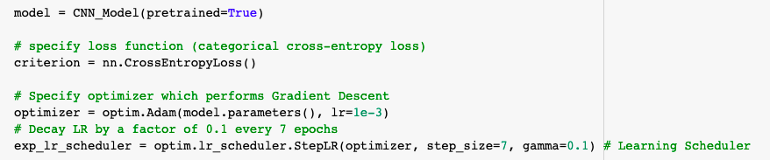

4.2 Evaluation metrics -

There are various metrics which are used to evaluate the performance of classification models, such as classification accuracy, sensitivity, specificity, precision, recall, confusion metrics and F1-score. Since the current test dataset does not contain large size (250 COVID-19 images, 250 Non-COVID image), accuracy and specificity are two proper metrics which can be used for reporting the model performance:

There are only four cases under which the images can be classified as-

***True Positive(TP) :*** When the model correctly predicts the positive class

***True Negative(TN) :*** When the model correctly predicts the negative class

***False Positive(FP) :*** When the model incorrectly predicts the positive class

***False Negative(FN)*** : When the model incorrectly predicts the negative class

*Evaluation Metrics-*

**Accuracy:** It is the ratio of correctly labelled subjects to the whole pool of subjects. Accuracy is the most intuitive one.

***Accuracy :*** (TP+TN)/(TP+TN+FP+FN)

**Precision:** Precision is the ratio of the correctly positive labelled by our program to all positive labelled.

***Precision:*** TP/(TP+FP)

**Recall / Sensitivity:** Recall is the ratio of the correctly positive labelled by our program to the actual true positive.

***Recall:*** TP/(TP + FN)

**F1- Score:**It is the harmonic mean(average) of precision and recall.

***F1-Score:*** 2 * (Recall * Precision)/( Recall + Precision)

**Specificity:**  Specificity is the ratio of correctly negative labelled to all positive and negative labelled classes.

***Specificity:*** TN/(TN+FP)

**Confusion Matrix:** It is a specific table layout that allows the more appropriate visualization of the performance of the algorithm. Each row in the matrix represents the instance in a predicted class with each column being the true class.

4.3 Classification Report-

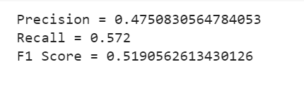



**VggNet-16**

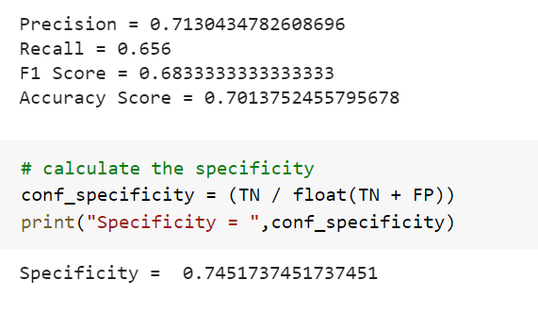

**ResNet-18**

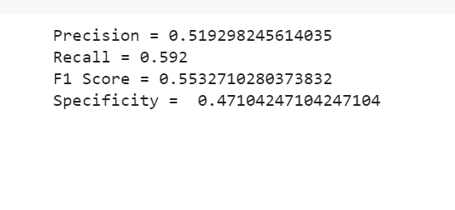

**ResNet50**

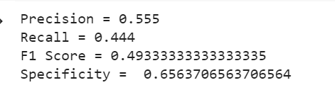

**DenseNet-121**

4.4 Accuracy Metrics-

|  |  |  |
| --- | --- | --- |
|  | Implemented Model | Results in Paper |
| ResNet18 | 70.13% | 98.9% [1] |
| DenseNet-121 | 84.55% | 97.6% [1] |
| VggNet-16 | 86.24% | 83.0% [2] |
| ResNet-50 | 92.32% | 90.6% [2] |

4.5 Confusion Matrix-

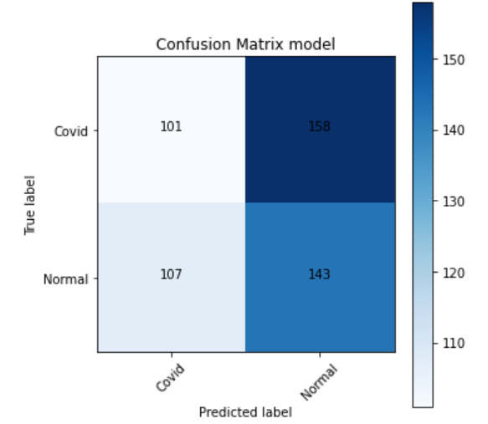

**VggNet-16**

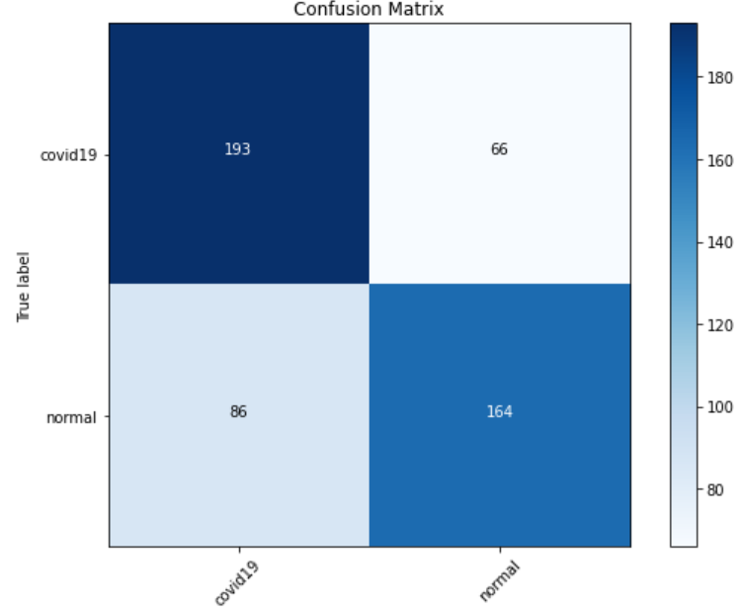

**ResNet18**

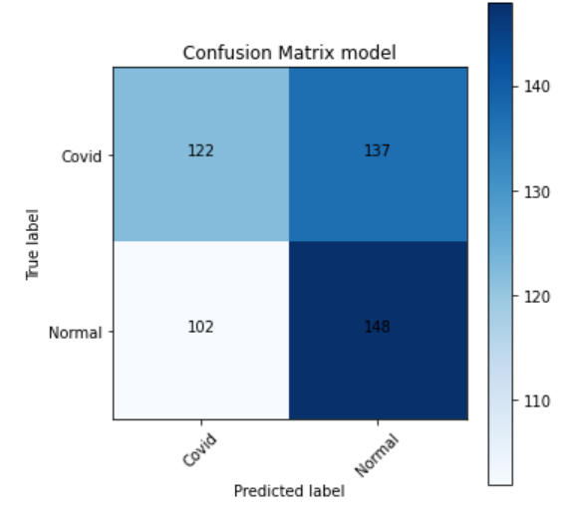

**ResNet50**

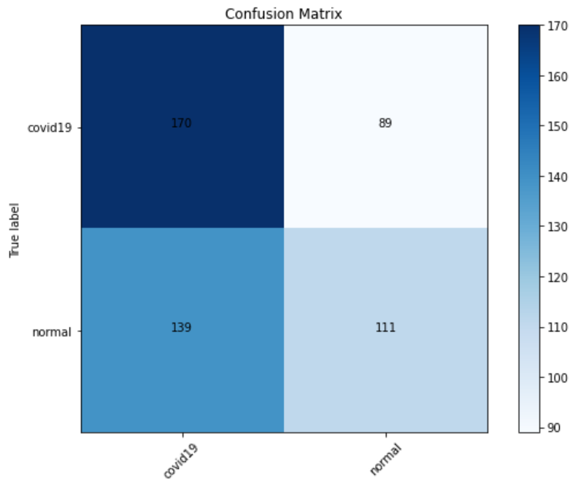

**DenseNet-121**

4.6 Loss and Accuracy Curve-

**VggNet-16**

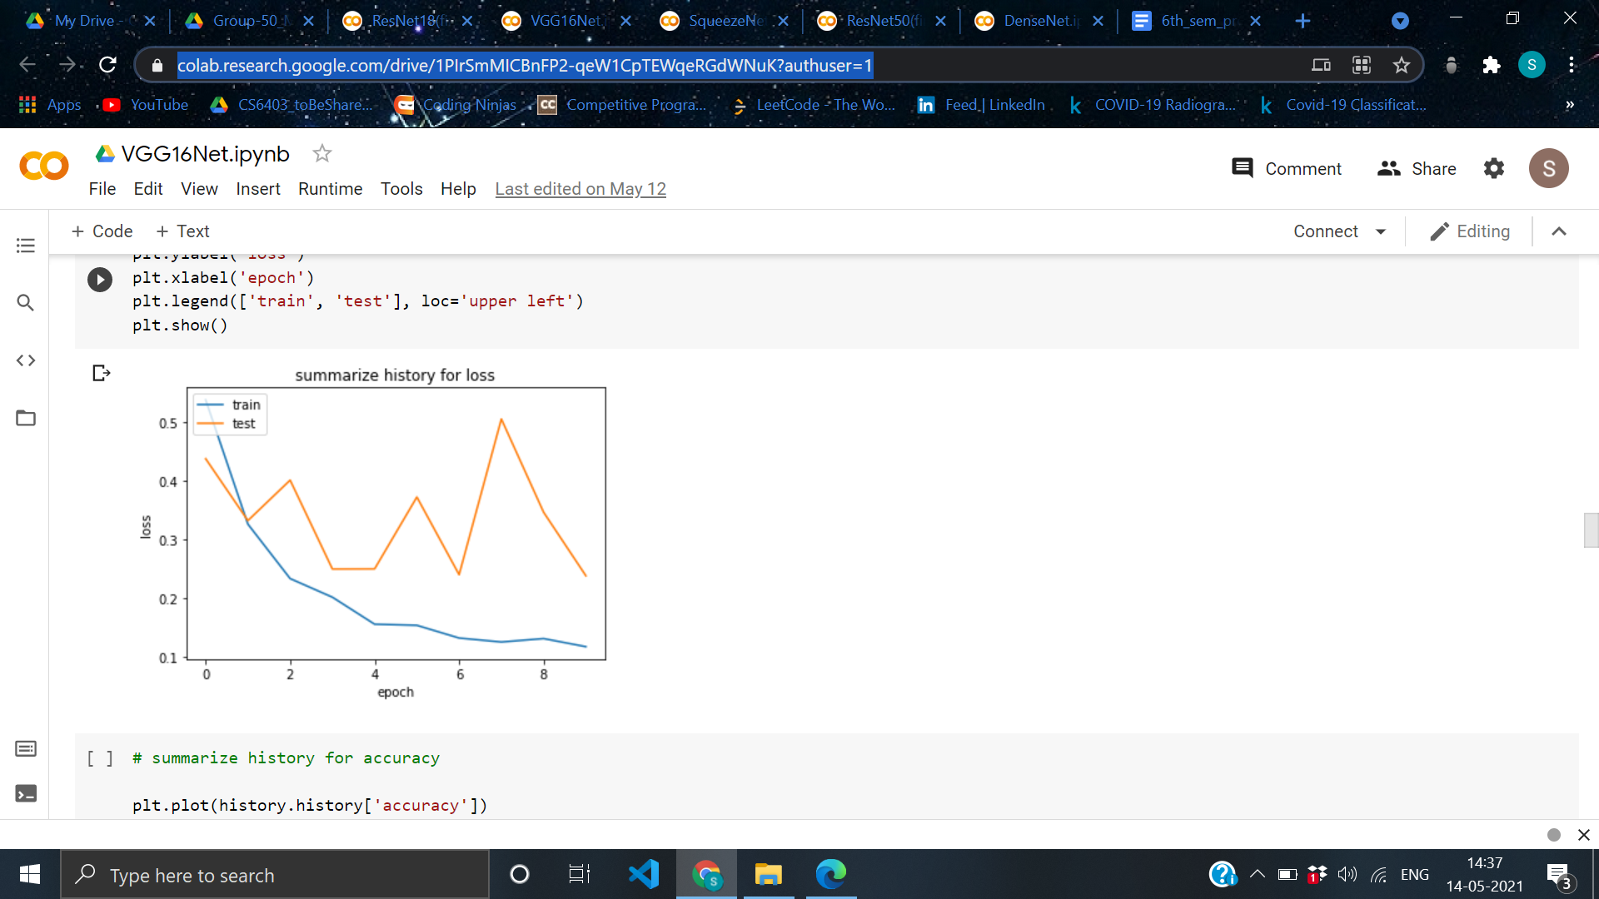 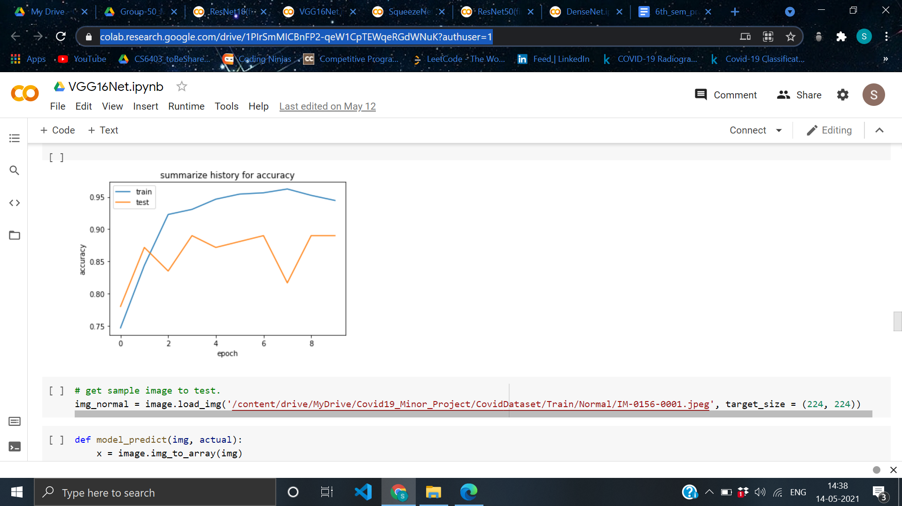

**ResNet50-**

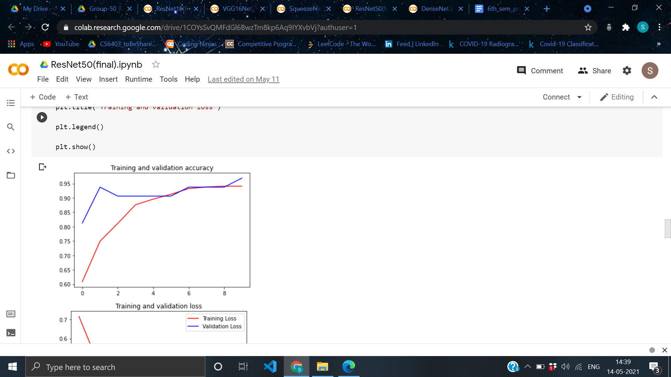 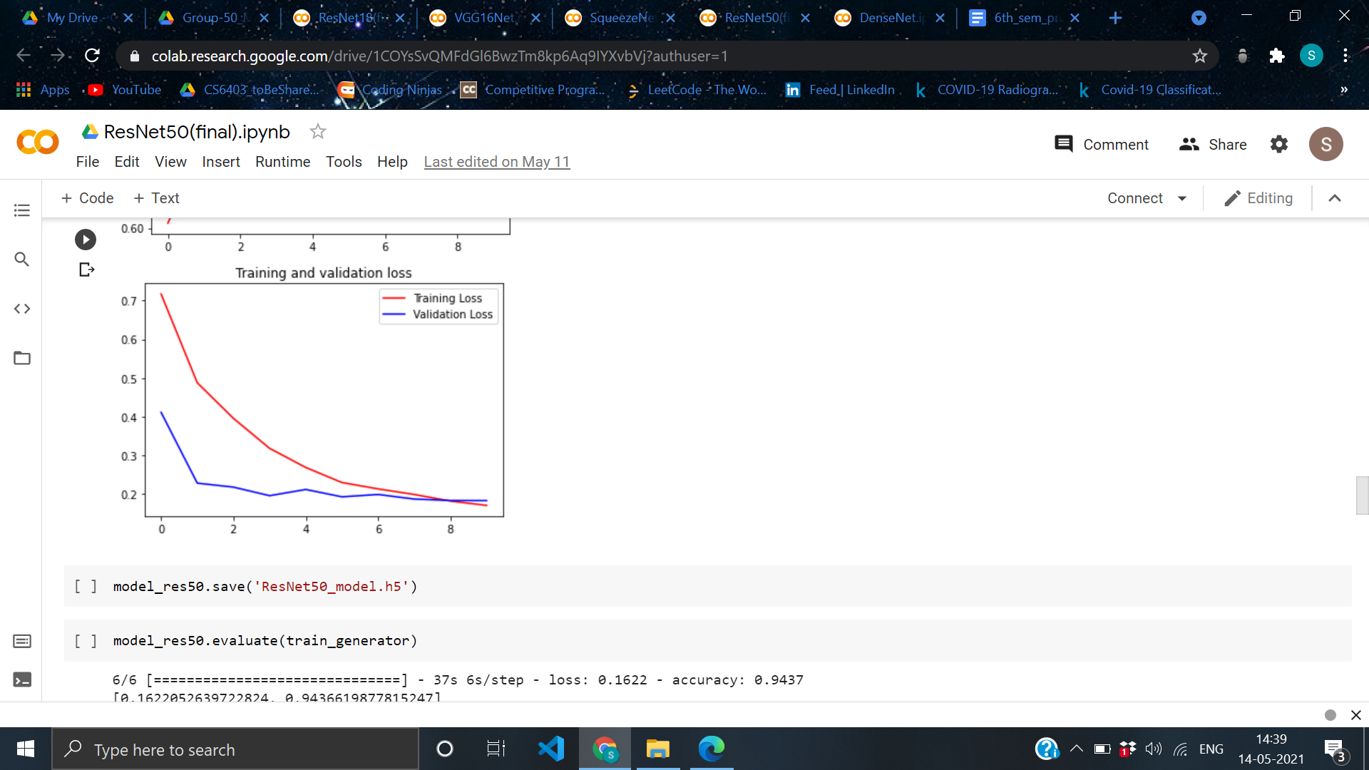

**Summary**

Here, we trained five authentic CNN’s which gave encouraging results in current times which are popular VggNet, ResNet18, ResNet50, SqueezeNet, and DenseNet-121 on COVID-Xray dataset. We have executed an in depth experimental investigation and evaluated the performance of all five models on the COVID X-ray test dataset , in terms of sensitivity, specificity, recall, F1-Score and accuracy. These models achieved around **92% of accuracy** in **testing se**t in case of **ResNet50(highest)** while the lowest goes around **70% in case of ResNet-50.**

As there were only a few COVID-19 images which were collected so far, we chose **specificity** to determine the best models and among all the models the highest specificity comes out to be  **around 75% of ResNet-18.**

As the there were only few COVID-19 images which were collected so far, to get more accuracy and authentic estimation than from now then more experiments are to be conducted on huge and clean labeled COVID-19 images

**References**

[1] Shervin Minaee,Rahele Kafieh, Milan Sonka,Shakib Yazdani, Ghazaleh Jamalipour Soufie-Deep-COVID: Predicting COVID-19 from chest X-ray images using deep transfer learning ; doi:10.1016/j.media.2020.101794

[2]Linda Wang, Zhong Qiu Lin and Alexander Wong - COVID-Net: A Tailored Deep Convolutional Neural Network Design for Detection of COVID-19 Cases from Chest X-Ray images ; doi: arXiv:2003.09871v4

[3] Yang, Y., Yang, M., Shen, C., Wang, F., Yuan, J., Li, J., Zhang, M., et al., 2020. Laboratory diagnosis and monitoring the viral shedding of 2019-nCoV infections. MedRxiv. Zeiler, M., Fergus, R., 2014. Visualizing and understanding convolutional networks. In: European Conference on Computer Vision. Springer, Cham

[4] Kong, W., Agarwal, P.P., 2020. Chest imaging appearance of COVID-19 infection. Radiology: Cardiothorac. Imaging ; doi:10.1148/ryct.2020200028. Krizhevsky, A., Sutskever, I., Hinton, G.E., 2012. ImageNet classification with deep convolutional neural networks. Adv. Neural inform. Process.Syst

[5] Cohen, J. P., Morrison, P., Dao, L., 2020. COVID-19 image data collection. arXiv:2003. 11597.

[6] Dong, C., et al., 2014. Learning a deep convolutional network for image super-reso lution. In: European Conference on Computer Vision. Springer, Cham.